Predict 400 Fall 2016 Final Exam – Zeeshan Latifi

1. Maximize 𝑧 = 4𝑥 + 6𝑦 subject to the constraints provided in the graph below. Using Python, recreate this graph and provide the optimal solution. You must also identify each linear inequality and the objective function in the legend of the graph that you create.

Use the graph provided to find the slope and y-intercept of all the equations.

(10,0) and (0,10) formula is y = -x+10

(3,0) and (0,3) formula is y = -x+3

(3,0) and (15,12) formula is y = x-3

Objective function calculation:

0 = 4x+6y so y = (-4/6)x

point slope formula (6.5 3.5)

y-3.5 = -4/6(x-6.5)

y = -2/3x + 47/6 this is the objective function

The maximum value of z is 60. Using 10 units of y and no units to of x.

Python code and output is shown below:

import matplotlib.pyplot

from matplotlib.pyplot import *

import numpy

from numpy import *

import pulp

from pulp import *

x=arange(0,100.1,0.1)

y=arange(0,100.1,0.1)

y1= -1*x + 10.0

y2= -1*x + 3.0

y3= 1*x - 3.0

y4 = (-2.0/3.0)*x + (47.0/6.0)

xlim(0,15)

ylim(0,15)

xlabel('x-axis')

ylabel('y-axis')

title('Final Number 1')

plot(x,y1,'r')

plot(x,y2,'b')

plot(x,y3,'g')

plot(x,y4,'--')

legend(['x+y <= 10','x+y >= 3', 'y-x <= -3 ','y = -2/3x + 47/6'])

x= [3, 6.5, 10]

y= [0, 3.5, 0]

fill(x,y, color='grey', alpha=0.2)

show()

# declare your variables

x1 = LpVariable("x1", 0, None) # x1>=0

x2 = LpVariable("x2", 0, None) # x2>=0

# defines the problem

prob = LpProblem("problem", LpMaximize)

# defines the constraints

prob += 1*x1 + 1*x2 <= 10

prob += 1*x1 + 1*x2 >= 3

prob += 1*x1 - 1*x2 <= -3

# defines the objective function to maximize

prob += 4*x1 + 6*x2

# solve the problem

status = prob.solve()

LpStatus[status]

max_amt = 4*(value(x1)) + 6*(value(x2))

# print the results

print('x1 is')

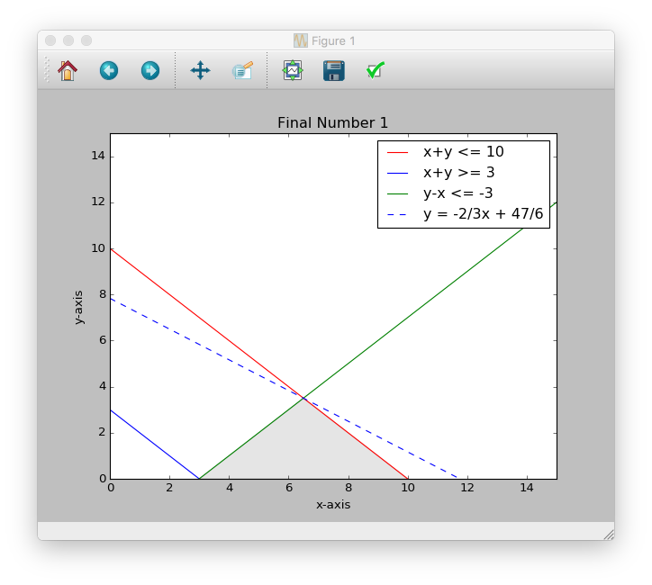print(value(x1))

print('x2 is')

print(value(x2))

print('The max amount is')

print(max_amt)

Output:

x1 is

0.0

x2 is

10.0

The max amount is

60.0

1. The manager of a concert hall estimates that 500 people attend each classical concert, 900 people attend each jazz concert, and 400 people attend each rock concert. In any given month, the total of the number of classical concerts and the number of jazz concerts may not exceed 11 and the number of rock concerts must be no more than 6. Furthermore, there should be twice as many rock concerts as classical concerts in any given month. How many of each type of concert should there be in a month in order to maximize attendance? What will that attendance be?

In order maximize the attendees, the concert hall should have 11 jazz concerts. They should not have any classical or rock concerts. The total number of attendees for the month would be 9900.

Objective Function = 500x1 + 900x2 + 400x3

Constraints:

x1 + x2 <= 11

x3 <= 6

x1 = (2)x3

See python code below:

import pulp

from pulp import *

# declare your variables

x1 = LpVariable("x1", 0, None) # x1>=0

x2 = LpVariable("x2", 0, None) # x2>=0

x3 = LpVariable("x3", 0, None) # x3>=0

# defines the problem

prob = LpProblem("problem", LpMaximize)

# defines the constraints

prob += 1*x1 + 1*x2 + 0*x3 <= 11

prob += 0*x1 + 0*x2 + 1*x3 <= 6

prob += 1*x1 - 2*x3 >= 0

# defines the objective function to maximize

prob += 500*x1 + 900*x2 + 400*x3

# solve the problem

status = prob.solve()

LpStatus[status]

max_num = 500*(value(x1)) + 900*(value(x2)) + 400*(value(x3))

# print the results

print('The number of classical concerts to have')

print(value(x1))

print('The number of jazz concerts to have')

print(value(x2))

print('The number of rock concerts to have')

print(value(x3))

print('The maximum number of attendees is')

print(max_num)

Output:

The number of classical concerts to have

0.0

The number of jazz concerts to have

11.0

The number of rock concerts to have

0.0

The maximum number of attendees is

9900.0

1. Researchers at Northwestern University have developed a piecewise function that can be used to estimate the body weight (in grams) of a female fox during the first 56 days of its life according to

𝑊(𝑡) = 50+2.85𝑡+0.6519𝑡1 +0.00804𝑡2 𝑖𝑓 0≤𝑡≤28

−1097 + 68.9𝑡 𝑖𝑓 28 < 𝑡 ≤ 56

Is this function continuous? Why or why not? Using Python, graph this function.

Since each piece of this function is polynomial, the only x-values where the function may be discontinuous is 28. If we take 28 from the left and the right, the values are not equal. Therefore, the function is not continuous.

50 + 2.85(28) + 0.6519(28)2 + 0.00804(28)3 = 462.991

-1097 + 68.9(28) = 832.2

Python graph below:

import matplotlib.pyplot

from matplotlib.pyplot import *

import numpy

from numpy import *

#Plot to show the two separate lines

x1=arange(0,28.0,0.001)

x2=arange(28.0,100.1,0.001)

y=arange(0,100.1,0.001)

y1= 50 + 2.85*x1 + 0.6519*x1**2 + 0.00804*x1**3

y2= -1097 + 68.9*x2

xlim(0,60)

ylim(0,1000)

xlabel('Days')

ylabel('Weight in Grams')

title('Final Number 3')

plot(x1,y1,'r')

plot(x2,y2,'b')

legend(['50 + 2.85x + 0.6519x^2 + 0.00804x^3','-1097 + 68.9x'])

show()

#Plot to show the two lines together

figure()

def W(x):

if x <= 28:

return 50 + 2.85*x + 0.6519*x**2 + 0.00804*x**3

else:

return -1097 + 68.9*x

x=arange(0,100.1,0.1)

y=arange(0,100.1,0.1)

vW = np.vectorize(W)

xlim(0,60)

ylim(0,1000)

y = vW(x)

xlabel('Days')

ylabel('Weight in Grams')

title('Final Number 3')

plot(x,y)

show()

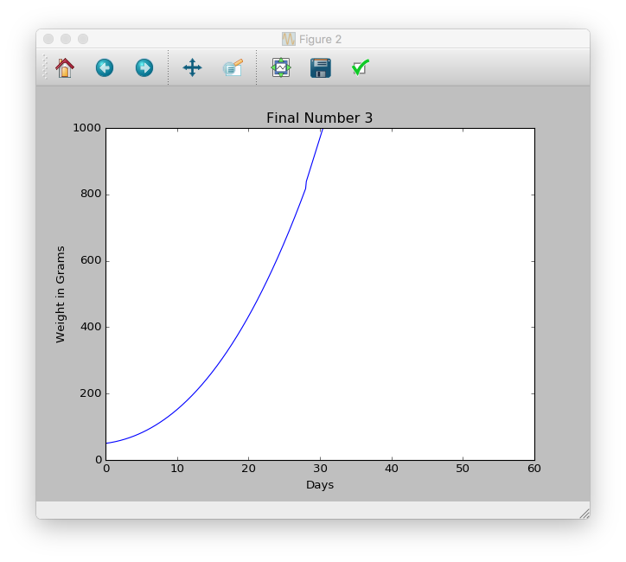

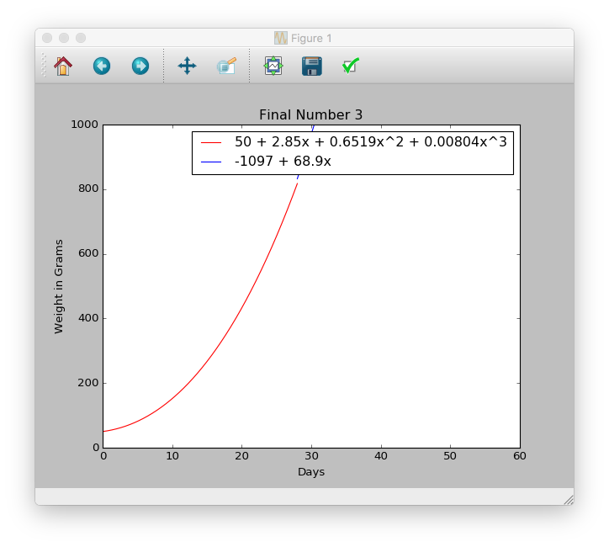

1. $2900.00 is deposited into an account with an interest rate of 𝑟% per year, compounded monthly. At the end of 8 years, the balance in the account is given by

𝐴=2900(1+ 𝑟/1200)^96

At what interest rate is the balance changing at a rate of $372.62 per percent?

A = 2900 (1 + r )^8*12

12(100)

372.62 = 2900 (1 + r )^8*12 - 2900 (1 + r )^0*12

12(100) 12(100)

8-0

372.62*8 = 2980.96

2980.96 = 2900 (1 + r )^8*12 - 2900 (1)

12(100)

2980.96+2900 = 5880.96

5880.96 = 2900 (1 + r )^96

12(100)

5880.96/2900 = 2.02792

2.02792 = (1 + r )^96

12(100)

2.02792^(1/96)

1.00739 = 1+ r/1200

1.00739-1 = 0.00739

0.00739 = r/1200

0.00739 * 1200 = 8.87024% = r

The balance changing at a rate of $372.62 occurs when the interest rate is at 8.87024%.

1. The natural resources of an island limit the growth of the population to a limiting value of 4,048. The population of the island over time is given by the logistic equation

𝑃(𝑡) = 4048 / (1 + 4.9𝑒-0.37t)

where 𝑡 is the number of years after 1980. What is the rate of change of the population of the island in 1986?

Instantaneous rate of change at t=6

4048 d/dt = 1/(1 + 4.9𝑒-0.37t)

4048 d/dt = (1 + 4.9𝑒-0.37t)-1

u = 1 + 4.9𝑒-0.37t

d/du = -1/u2

d/dt (1 + 4.9𝑒-0.37t) = 1.813e-0.37t

4048 (- 1 ) * (-1.813e-0.37t)

(1 + 4.9𝑒-0.37t)2

7339.02e-0.37t

(1 + 4.9𝑒-0.37t)2

1986-1980 = 6 = t

P = 339.533

The rate of change of the population on the island in 1986 was 339.533 people

1. The average monthly rent for a 1000 sq. ft. apartment in the Evanston area from 1998 through 2005 can be approximated by the function 𝑓 𝑡 = 1.603𝑡4 − 23.258𝑡3 + 62.12𝑡2 + 6.992𝑡 + 1010, where 𝑡 is the number of years since 1998. Using Python, find the year during which rents were increasing most rapidly. What was the highest rate of increase?

Rent is increasing most rapidly during 1999, at approximately $67.87.

Python Code:

import matplotlib.pyplot

from matplotlib.pyplot import *

from scipy.misc import derivative

import numpy

from numpy import poly1d, linspace

#show the derivative of the formula

p=poly1d([1.603, -23.258, 62.12, 6.992, 1010])

print ('Number 6 Degree Polynomial')

print p

print ('\nFirst Derivative')

h= p.deriv(m=1) # First derivative with m=1.

print h

def f(x):

return 1.603*x**4 - 23.258*x**3 + 62.12*x**2 + 6.992*x + 1010

#evaluate the derivative at within the interval [0:7]

for i in range(8):

print(derivative(f,i, dx = 1e-6))

print('Rent is increasing most rapidly during year 1 or 1999, at')

print(derivative(f,1.0, dx = 1e-6))

Output:

Number 6 Degree Polynomial

4 3 2

1.603 x - 23.26 x + 62.12 x + 6.992 x + 1010

First Derivative

3 2

6.412 x - 69.77 x + 124.2 x + 6.992

6.99200001009

67.8700000663

27.6719999874

-75.1300000275

-202.064000007

-314.658000377

-374.43999986

-342.937999449

Rent is increasing most rapidly during year 1 or 1999, at

67.8700000663

1. Phil is creating a flyer to contain 27 in2 of printing with a 3-in margin at the top and bottom and a 1-in margin at each side. What overall dimensions will minimize the amount of paper used?

27 = L*W

W = 27/L

L = 27/W

3 in margins on each side for L, 1 in margins on each side for W

(L+6)*(W+2)

(27/W + 6) * (W+2)

27 + 54/W + 6W + 12

(54/W) + 6W + 39

d/dw = (-54/W2) + 6

(-54/W2) + 6 = 0

6 = (-54/W2)

6W2 = 54

54/6 = 9

W2 = 9

W = 3

L = 27/3 = 9

(9+6) * (3+2) = 75 in2

The minimize the overall amount of paper that is used, Phil must create a flyer with the printing area of 27 in2 with the dimensions of the length at 9 in and the width at 3 in. This will result in the minimum overall area of the paper being used at 75 in2

There are only 4 options for the paper as listed below. When using the formula *A = (L+6)*(W+2)* these are the results we get

|  |  |  |
| --- | --- | --- |
| Options | L x W | Total Area of Paper Used |
| 1 | 9x3 | 75 |
| 2 | 3x9 | 99 |
| 3 | 27x1 | 99 |
| 4 | 1x27 | 203 |

1. In 2015 the measles epidemic was growing according to the rate

𝑁’(𝑡) = 106𝑡/(𝑡2 + 2)

where 𝑁(𝑡) is the number of people infected after 𝑡 days. Find a formula for the number of people infected after 𝑡 days, given that 47 people were initially infected. How many people were infected after 20 days?

𝑁’(𝑡) = 106𝑡/(𝑡2 + 2)

u = (t2+2)

u’ = 2t

106t/2t = 53

53∫ (1/u) du

ln(u)

53 ln(t2+2) + 47

53 ln((20)2 +2) + 47 = 364.81

364 people were infected after 20 days

1. The rate of change in a person’s body temperature with respect to the dosage of 𝑥 milligrams of a certain drug is given by

𝐷’(𝑥) = 4/(𝑥+5)

One milligram raises the body temperature 2.5°C. Find a function giving the total temperature change. Using Python, graph both 𝐷(𝑥) and 𝐷′(𝑥).

Use the indefinite integral rule

D(x) = 4 ln(x+5) + C

D(1) = 4 ln(1+5) + C

2.5 = 4 ln(6) + C

C = 2.5 – 4 ln(6)

D(x) = 4 ln(x+5) + [2.5-4 ln(6)]

4 ln(x+5) – 4 ln(6) = 4 ln[(x+5)/6] + 2.5

Function that provides the overall temperature change: D(x) = 4 ln[(x+5)/6] + 2.5

Python code for graph:

import matplotlib.pyplot

from matplotlib.pyplot import *

import numpy as np

from numpy import poly1d, linspace

def d(x):

return 4.0*np.log((x+5.0)/6.0)+2.5

def Dd(x):

return 4.0/(x+5.0)

x=linspace(-30,30,10000)

y=d(x)

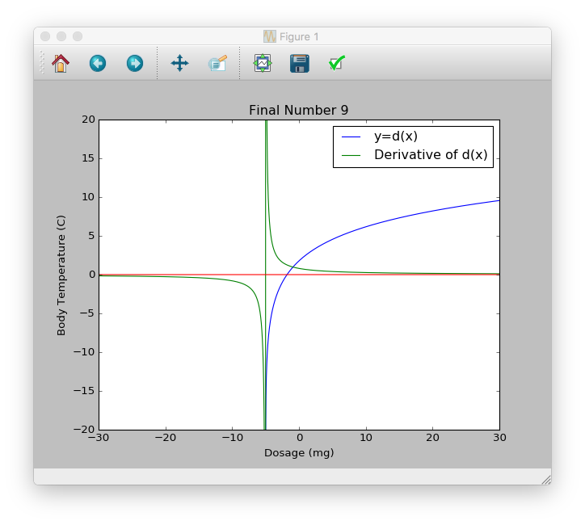yg=Dd(x) # These statements define points for plotting.

y0=0*x # This statement defines the y axis for plotting.

plot (x,y,label ='y=d(x)')

plot (x,yg,label ='Derivative of d(x)')

legend(loc='best')

ylim(-20,20)

plot (x,y0)

xlabel('Dosage (mg)')

ylabel('Body Temperature (C)')

title ('Final Number 9')

show()

1. The age of randomly selected, alcohol-impaired driver in a fatal car crash is a random variable with probability density function given by

𝑓(𝑥) =0.1972/ (x0.5114)

over the interval [16,44]

Find the following:

(a) The expected age of a drunk driver in a fatal car crash.

(b) The standard deviation of the distribution.

(c) The probability that such a driver will be younger than 1 standard deviation below the

mean.

a)

$$μ= \int_{16}^{44}{\frac{0.1972}{x^{0.5114}}}$$

$μ= \int_{16}^{44}{x* \frac{0.1972}{x^{0.5114}}}$ dx

0.1972x (x-0.5114) dx

x-0.5114+1 = x0.4886

power rule = $\frac{x^{0.4886+1}}{0.4886+1}$

$$0.1972\int_{16}^{44}{\frac{x^{1.4886}}{1.4886}}$$

$0.1972\left[\left(\frac{{44}^{1.4886}}{1.4886}\right)-\left(\frac{{16}^{1.4886}}{1.4886}\right)\right]$ = 28.817 =

b)

dx - μ2

0.1972x (x-0.5114) dx

x-0.5114+2 = x1.4886

power rule =

- (28.817)2

- (28.817)2 = 65.6108

$\sqrt{65.6108}$ = σ = 8.10005

c)

$P (x≤μ- σ$)

28.817 – 8.10005 = 20.717

$$\int_{0}^{20.717}{\frac{0.1972}{x^{0.5114}}} dx$$

0.1972 (x-0.5114)

= 1.77464%

The expected age of a drunk driver in a fatal car crash is 28.817 years old

The standard deviation of the distribution is 8.10005

The probability that a driver will be younger than 1 standard deviation below the mean is 1.77464%.